Adaptive Switches

Adaptive Switches: An Access Tool.
What is an adaptive switch?
Lets start with an overview of switches. We are all familiar with switch technology. Whether you are turning on a light, starting the barbecue, switching (like that!) on the television, you are constantly using switches. Why even the keyboard and mouse you are using are replete with switches. We all use them but few of us, if pressed, could define one.
At its simplest, a switch is a way to turn on or off electricity. Let's take the example below, a portable TV/radio, as an example of a typical switch
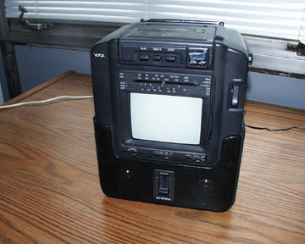
The faceplate of this device is covered with switches. One switch turns on or off the power (the simple switch). Another switch changes the channel on the television while a third switch adjusts the radio tuning. We all have probably used switches many times in the last 24 hours. For many people with disabilities, however, this simple task is infinitely complex because of their limited fine motor skills or visual abilities. This is where an adaptive switch comes in.
Each adaptive switch is an interface between the person with a disability and the technology that:
- modifies the standard switch to be accessible to the person with a disability, and
- is designed to capitalize unique ability of that individual
In the photograph below, an adaptive switch (the large red circle) has been used. This switch is plugged into the TV/radio set. By plugging the switch into the set, the flow of electricity is diverted from the TV/radio out through the connecting wires to the switch. When the switch is not activated (in this case not pressed), the flow of electricity is broken and the TV/radio cannot work - even though the switch on the set is physically turned on. It is only when the person presses down on the large red plate that the circuit of electricity is complete and the device can do work.
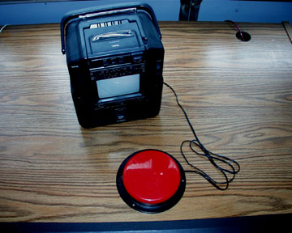
An adaptive switch, such as the one illustrated above, alters the interaction scheme between the user and the device making a previously inaccessible method (the buttons are too small and inaccessible for persons with poor motor skills) accessible by using a movement pattern or skill that the person with a disability can more easily perform. This is what an adaptive switch is and why they are so important in assistive technology systems. Next, you will learn about the different types of switches, each capitalizing on a unique skill or ability the person with a disability has.

Types of adaptive switches.
Switches can be classified along three dimensions:
- the number of functions they perform.
- the response they use to produce switch actions.
- the activation attributes.
Switch functions:
Single function switches are the most commonly used adaptive switches. This type of switch performs one function (i.e., on/off)
this switch has only one function - on or off. The switch may only be in one of the states at any one moment in time. | 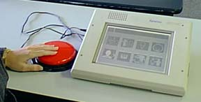
Multiple function switches may perform two or more functions.
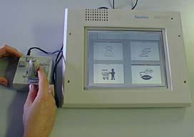 | This multiple function switch, in contrast to the previous switch, has 5 possible on/off switches.
By increasing the number of switches, the number of functions increases also. A dual switch will allow the user to have 4 separate functions. For example:
Switch Action.  1=on, 2=on:  1=on, 2=off:  1=off, 2=off:  1=off, 2=on: | Function.  Cursor up.  Cursor down.  Cursor right.  Cursor left.
Switch activation attributes.
Adaptive switches can have any of the following activation attributes:
- Momentary - the action is only sustained as long as the person continues to press the switch.
- Latched - the action, once initiated by a switch activation, continues until the person presses the adaptive switch again.
- Timed - the action, once initiated by a switch activation, continues for a set amount of time.
Response used to produce a switch action.
Adaptive switches can also be categorized by the response they use to produce a switch closure or other action. Several types are illustrated and described below.

Pneumatic.
In this photograph the person is issuing commands by sipping or puffing. The resulting positive or negative pressure created by the sip or puff initiates switch opening or closure. | 

Pressure
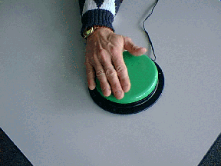 | This person is using a switch that responds to pressure. By compressing the switch, they create switch actions.

Optical
Here, the man blinks to interrupt an infrared beam. When the beam is broken, the switch closes. | 

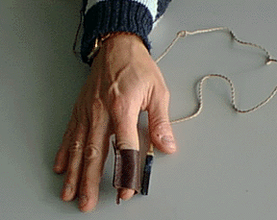 | Magnetic  Magnets can be used to function as a switch. When the magnetic fields of the two magnets in this switch intersect, the switch closes.

Sound
A person can use their voice (or any sound they can make) to operate a switch. In this photo, the person is performing switch operations by vocalizing "ahhh". | 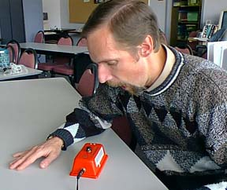

Connecting Switches to Devices
A switch by itself is not very useful. Each switch must be connected to a device or an appliance to help the person with a disability. One way to connect a switch to a device that is battery powered (DC powered) is by using a battery interrupt. Battery interrupts are used to divert the flow of direct current (batteries - 1.5v, 6v) to an adaptive switch. Each battery interrupt is composed of a wire, a female jack, and two copper plates (electrical conductors) with an insulating material - typically plastic - sandwiched between them. The interrupt is placed between two batteries as pictured below (one battery interrupt is placed on the table; the other is inserted between the batteries in the rear compartment of the TV/radio).
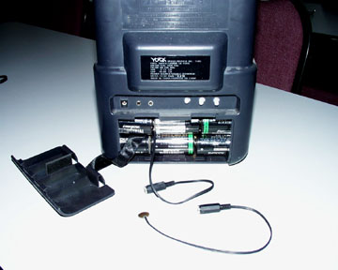
The switch is then connected to the interrupt and, voila', you have a fully accessible TV/radio that can be operated with the press of a hand (or any other body part) - see below.
But what about AC (wall) current? Good question. You would not want to attach a switch to AC current without modification because this arrangement would send all 220 volts right through the switch. Chances are that the person would only have one opportunity to try out the switch before they were zapped. This would not be good. Fortunately, there are devices that transform AC current into DC current and allow the person to effectively (and safely) use adaptive switches with AC controlled appliances. One such device is shown below (the box to the right of the TV/radio).
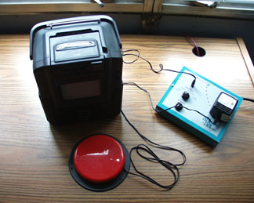
Battery interrupts and transformer come in a variety of sizes, shapes, and are available from many vendors. To look at some of these nifty devices visit the AbleNet site by clicking on the links below
Battery Interrupters
Simple Power Controls
Simple Timers and Activation Control Units

Switch Positioning.
One of the most important aspects of using switches is where and how the device is positioned.
- A switch that is not in a good position is only slightly more useful to the person than having no switch at all.
- Conversely, a properly positioned switch will allow the person to be more independent and productive.
Factors to consider in positioning a switch:
A switch may be positioned so that the person can use a variety of movement patterns to operate other devices or appliances. For our purposes, we will group these potential locations into three broad classes, each having specific advantages and disadvantages. Click on the buttons next to the photo below to learn about the potential for switch use for each group.

Head  The head is often the last remaining access site for persons with severe, progressive disabilities such as ALS or Fredricks Ataxia. For this reason, it is appropriate to consider the person's head as a potential access site. However, the head is involved in so many of our daily activities (vision, perception) that to restrict it by using a switch that requires head movements may be counterproductive.  Bottom of Form | 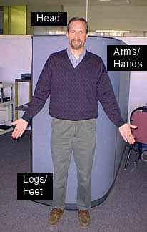 | Arms/Hands  Hands and arms are the most often used anatomic site for switch access and use. To use ones hands or arms, however, will require that the person have good coordination. The advantages: in the field of vision, more accepted access site, many products are designed to be interacted with using hands or arms. Disadvantages: these appendages are frequently used for other tasks as well.
Legs/Feet
Legs and feet are one of the most frequently overlooked anatomic sites for switch use. Legs and feet do not often possess a high degree of fine motor coordination, yet they are sufficient for many tasks. Advantages: typically not engaged in other tasks. Disadvantages: often out of the field of vision (especially when a person is seated in a wheelchair)

Determining where to position a switch, how to use the switch and testing the switch out.
Click on the links below to take you to sites which illustrate the following principles.
- Choosing a Movement. Movements the person uses to activate a switch must be (a) under voluntary control of the user and (b) reliable.
- Identify an appropriate switch.
- Test the switch. Conduct comparative assessments of the switch site(s) and switch(es). Collect information about each of the following variables:
a. The accuracy of switch activation. Can the person press the switch when they want to or when others cue them?
b. The amount of fatigue the person experiences when using the switch for varying amounts of time.
c. The latency between an intention to press a switch and the actual switch activation.
d. The persons preferences. Observe or interview the person to determine their preferences for switches and switch positions.
- Remember: The person will always do what is (a) physically easier (b) the most consistent in accessing the desired goal, and (c) faster in achieving the goal.

